8401 W 3rd St, Los Angeles 90048, another at 453 Colyton Street

* This piece is part of the Global Angel Wings project created by Colette Miller. It is a life size, interactive art display around the streets on Los Angeles. The meaning behind the wings is to “remind humanity that we are the angels of the earth.” The project has grown and expanded globally but its original purpose to bring people from all backgrounds together and show the goodness in humanity has remained the same.

Collaboration between Christina Angelina (@starfightera) and Fanakapan. (@fanakapan)

* Arts District, Downtown L.A. @ 4th Street and Merrick, LA 90012

* Christina Angelina is a LA native and UCLA grad who uses large and unique landscapes as her canvases. Although Angelina has taken her talents around the world, the chaos of the Venice Beach boardwalk has always been home and she continues to portray her interpretation of real people reflecting raw emotions such as fear, hope, and serenity. This mural is located in the Arts district in downtown LA: a beautiful and intimate moment between two women that is sure to make you stop and stare, feeling every emotion she put into the piece.
* "My work is emotional, intuitive, reflective, and I try to always consider the location, both aesthetically and energetically," she says. "I am mostly inspired by personal experience: people and places and artwork that I come in contact with" (The Creators Project)

* Street artist, David Puck paints murals around the country portraying the beauty of all people, while bringing awareness to civil and LGBTQ rights in a loud and colorful way. This painting of drag queen, Asia O’Hara is located on the Hollywood walk of fame paired with the words, “The Caterpillar dissolves into Liquid to rebuild as a Butterfly.”
* “Holding on to futile permanence is a symptom of fear, a fear that the future unknown is less controllable and might be worse, but by resisting the unknown we spoil today, and resist the opportunity for something more beautiful to be created” – David Puck

1447 Lincoln Blvd, Santa Monica, California.

Street artist, David Puck took to the streets to do what he is best at during the heat of the Black Lives Matter protests in LA. The summer of 2020 was a crucial moment for the civil rights movement and those who stood with the movement showed their support in various ways. David showed his support and respect for BLM through his incredible artwork featuring the strong black queer voice of Jaida Hall.

American Tropical

* *125 Paseo De La Plaza*
* The mural titled American Tropical was created by artists David Siqueiros who left Mexico and came to Los Angeles. The piece was created as a political statement about US Imperialism in Latin America. The mural is almost 100 years old as the Getty has worked against time to bring this piece back to life. One of the main features is a Mexican Indian crucified on a cross underneath an American eagle with Mayan pyramids and other Latin American symbols in the background.

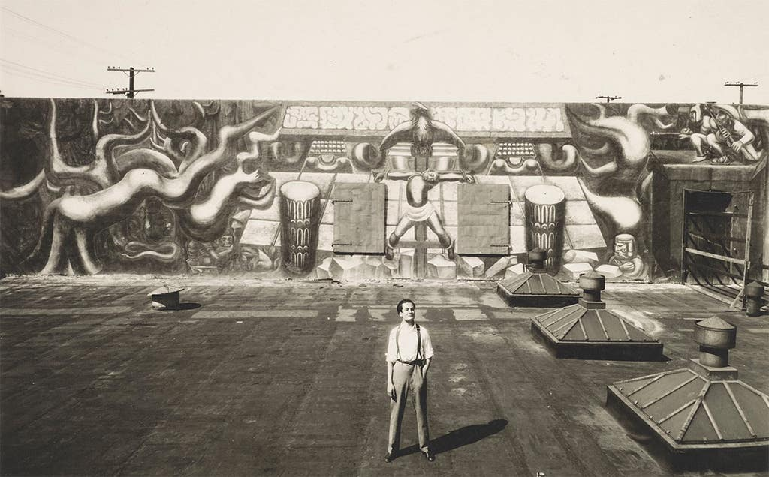

##### Skid Row Mural

##### 6th Street and San Julian Street

* Somewhere most people wouldn’t expect to find great art, This Skid Row mural was voted as the best new street art piece in LA a few years ago. This area of LA is one of the most populated with homeless people in the whole city. One aspect that makes this piece so special is that it is created solely by residents of skid row. This work is personal and is communicating a message for everyone to see.

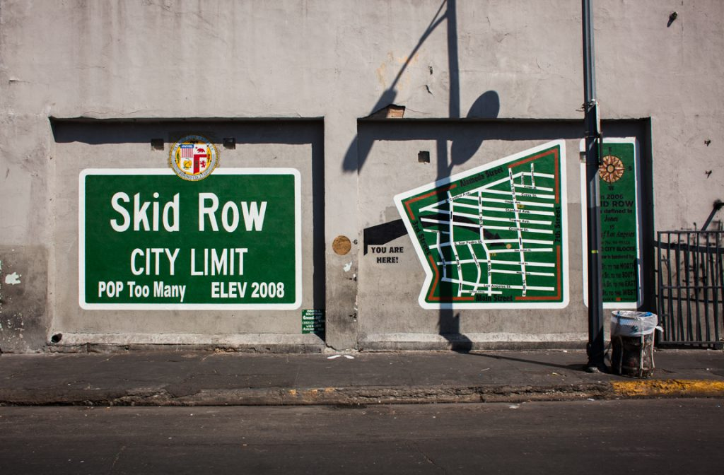

* **5791 Obama Blvd, Los Angeles**
* Some street artists don’t credit their work, but their message isn’t any less powerful. Driving through downtown LA this large mural caught my, I couldn’t help but pull out my phone at a red light and take a photograph. Kobe Bryant and Nipsey Hussle are icons to millions around the world and heroes to anyone in the city of LA.
* Nipsey was committed to lifting the people of South LA up and was a light for the youth or anyone struggling to make it. His impact is far reaching and long from being forgotten shown by the hundreds of murals around the city celebrating his life and words.
* For those who grew up in Los Angeles, Kobe’s passing felt like an unimaginable loss. His impact went beyond basketball and the city continues to ride for and celebrate one of their greatest heroes.
* This beautiful, detailed piece portrays two people who are LA culture.

Santa Monica, California

* Art is used as a celebration for diversity, an understanding that the different people, foods, ethnicities, and cultures are the beauty and the strength of the ciy.